SE 445 – HW1 Report
Lead Capture Workflow using n8n
Name: Yaren Köroğlu
Course: SE 445
Instructor: Ruken ZİLAN

1.Introduction
This Project aims to build a lead capture system using n8n. System takes and processes the data which comes from user and saves to in Google Sheets. It uses AI agent powered by OpenAI’s GPT-4o-mini model to summarize and categorize the incoming message.

2. Workflow Overview
Webhook -> Data Processing -> Google Sheets -> AI Agent
Workflow begins with a webhook that receives user input. In this step, name, e-mail and message information are taken from user. After that, this all information is processed, organized, and converted into a suitable format. Processed data is saved to Google Sheets as a new line for storing permanently. Finally, a summary is generated based on the user's message, simulating an AI response.

3. Components Explanation
1) Webhook: This is the entry point of the system. It gets information which comes from users.
2) Code: All data are organized and made mapping operation. Also, a timestamp is added to data.
3) Google Sheets: All processed data are saved in Google Sheets as a new line. Thus, all data can be saved permanently.
4) AI Step: Receives the stored data and generates a natural language summary.

4. Test Case
Input:
name: Yaren
email: yaren@test.com
message: hello
Explanation: System is tested using mock data instead of using real user data. Thus, this situation is simulated like a data is coming from a user. The workflow is executed successfully; data are saved in Google Sheets and AI Agent produced a categorized summary of the message.

5. Conclusion
In conclusion, the created workflow successfully receives, processes, and records user data. It also produces an output with AI Agent. The system meets all the requirements of the assignment.
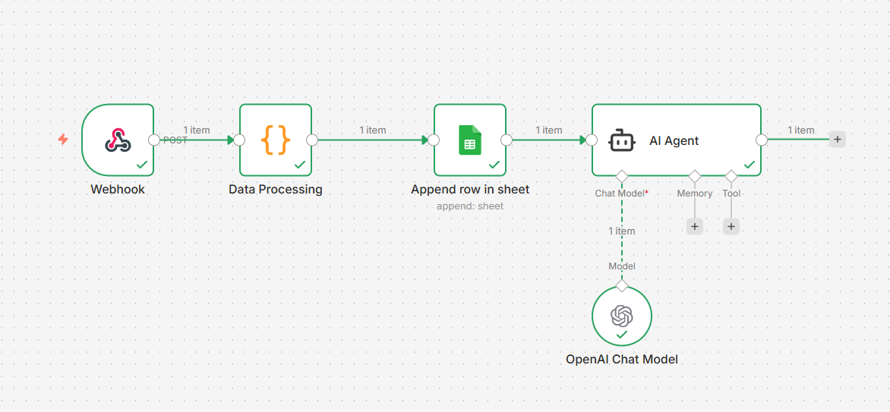

Figure 1 n8n workflow illustrating webhook, data processing, Google Sheets integration, and AI Agent steps.
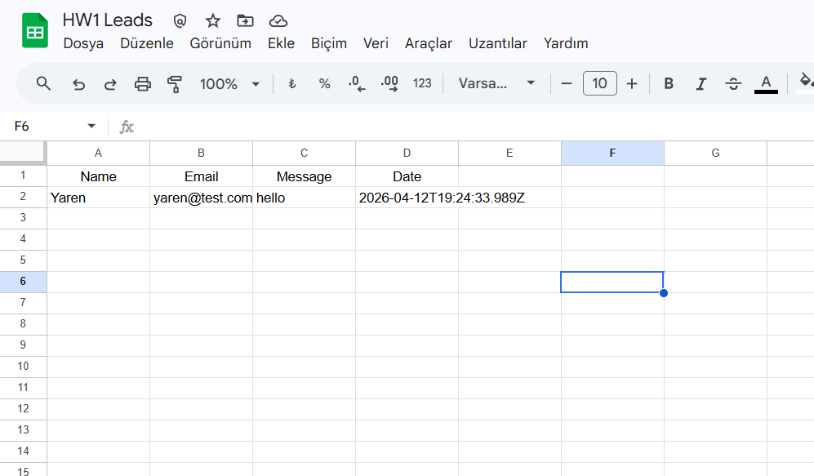
Figure 2 Data successfully stored in Google Sheets after workflow execution.

GitHub Repository:
https://github.com/yarenkrg/hw1-lead-capture

